**Project overview**

**Objective:** To sell the commodity of farmers such as crop to companies or buyers before it comes to yield with pre booking facilities according to needs of buyers.

**Advantages:**

1. NO crop wastage by farmers or buyers due to rotten

Eg: tomatoes get rotten within days where as Bengal gram can be used even after many days/months

1. Pre booking by companies for their requirements instead of hurrying when need comes
2. Best price for farmers
3. Farmers can fix their own prices for their hardworked commodity.

**Users:**

1. Farmers (sellers)
2. Middlemen / Quality checkers
3. Companies (buyers)

**Use cases:**

1. Farmers can sell their products to either companies or other buyers
2. The buyers may be companies or other farmers
3. Middlemen or quality checkers exist at village level to check the quality of commodity requested by buyers /companies/other farmers
4. Middlemen continuously communicate with farmers and companies/buyers for making the selling procedure transparent with buyers.

**Use case diagram on types of users and their use with application:**

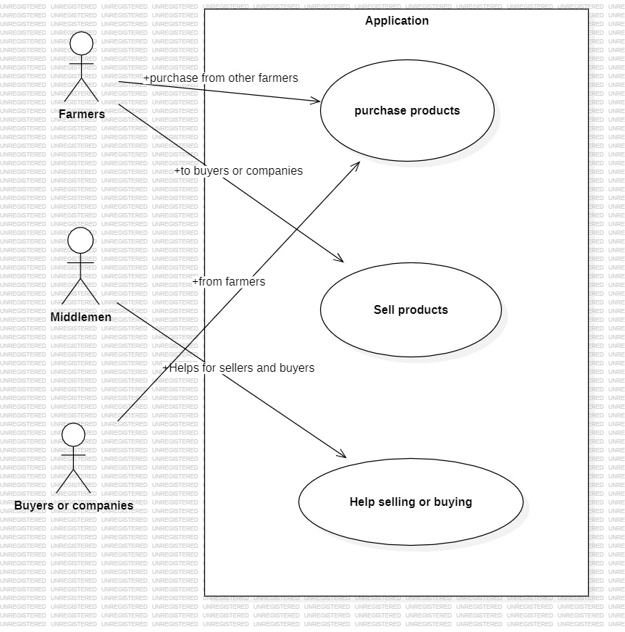

**Types of data required:**

1. Farmers / sellers list
2. Companies list
3. Buyers list
4. Quality checking data
5. List of commodities

**Data structure for each:**

Farmers: (when companies wants all the sellers list)

1. Name
2. Location
3. Commodity produced
4. Quantity of commodity
5. Price average
6. Rating to farmer
7. Contact

Companies: (when farmers want to know about buyers)

1. Commodities usually ordered list
2. Contact details
3. Price range offered for each commodity (average price)
4. location
5. rating

Quality check data parameters: ( when companies/ buyers want to check for quality of commodity)

1. commodity
2. seller name
3. rating of seller / farmer
4. rating of product (usually out of 10)
5. usual quality standards

List of commodities: (when buyer wants to know the supported items from application, our application,)

1. commodity name
2. no of sellers available (within 2 months)
3. least price per quintal
4. highest price per quintal

**Website designs:**

